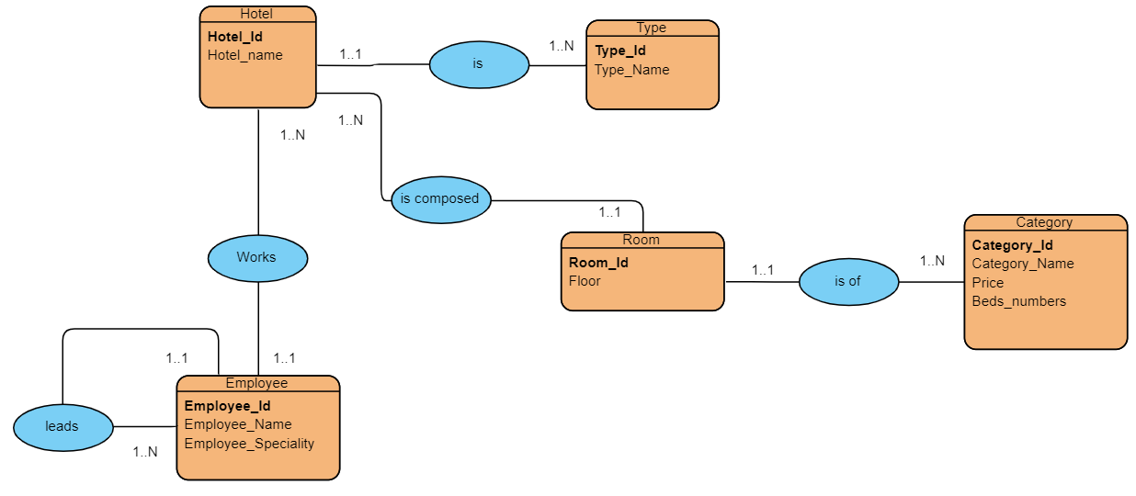

Hotels(Hotels-id,Hotels-name,#Type-id)

Type(Type-id,Type-name)

Room(Room-id,Floor,#Hotels-id,#Category-id)

Category(Category-id,Category-name,Price,Beds-number)

Employee(Elplyee-id,Emplyee-name,Emplyee-speciality,#Hotel-id)